**Special English Library Project - Funded by late Mrs Marie Pitiyage**

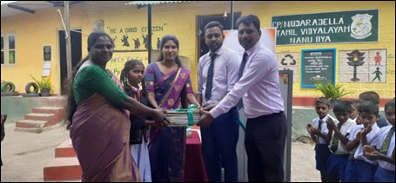

In the February of 2022 CandleAid was gifted LKR 3 million from the estate of the late Mrs Marie Pitiyage, to be used to open English Book Only (EBO) Libraries in small schools mainly located in rural Sri Lanka. Late Mrs Pitiyage had been an English teacher who had a great interest to make english books available to children in remote schools.

CandleAid planned to open 30 libraries and as at 31 December 2022, 23 of them were opened. 2 more are ready to be opened. The locations for the balance 5 are earmarked and awaiting confirmation.

CandleAid is deeply grateful to Late Mrs Marie Pitiyage and the executors of her estate for enabling this meritorious task. Below is a list of libraries opened as at 31 December 2022.

1. *A picture containing text, tree, person, outdoor

   Description automatically generated*St.Xaviers Girl's College (Mannar)
2. Don Bosco School of Excellence (Kilinochchi)
3. Agraoya Tamil College (Rozella)
4. Kelewa Sumana Viduhala (Palugaswewa)
5. Senadiriyagama Primary School (Palugaswewa)
6. Vidyaloka Maha Vidyalaya (Thennekumbura)
7. Mahawatta Maha Vidyalaya (Kundasale)
8. Meegahajadura Maha Vidyalaya (Sooriyawewa)
9. Chankani Sivapragasa Hindu Primary School (Chankanai)
10. *A group of people sitting at tables

    Description automatically generated with low confidence*Adhikarigoda Sri Gnanissara Kanishta Vidyalaya (Kalutara)
11. Diamond Jubilee College (Gorakapola)
12. Kalupahana Junior School (Poruwadanda)
13. President Model Primary School (Pasyala)
14. Wewaldeniya Maha Vidyalaya (Weweldeniya)
15. Sri Siddhartha Maha Vidyalaya (Danowita)
16. Siri Mihindu Maha Vidyalaya (Radawadunna)
17. Piyarathana Kanishta Vidyalaya (Pitigala)
18. Wanigasekara Maha Vidyalaya (Matara)
19. All Saint College (Galle)
20. Rukmale Maha Vidyalaya (Rukmale)
21. Alapaladeniya Secondary School (Morawaka)
22. Giridara Sri Bodhi Primary School (Kapugoda)
23. Udaradella Tamil Primary School (Nanu-oya)