**SPECIAL FOOD FUND – A SUMMARY OF OPERATIONS**

**AS AT 31 Dec 2022**

CandleAid’s above initiative to gift dry rations to the value of LKR 10,000 per family is cruising smoothly. 89 coordinators from all parts of Sri Lanka have been working with efficient commitment to get this project off the ground and make it work.

We started on the 28th of June and by 31 Dec 2022 we have gifted 1146 families dry rations worth LKR10,000 each.These included much needed food items and cooking needs such as rice, dhal, chickpeas, flour, sugar, tea, milk powder, dry fish, canned fish, soya meat, oil, spices, onions, etc. They carried them home on their shoulders, on bicycles, in trishaws, in buses – what was equally apparent was their joy, relief and gratitude. To some the rations were delivered to their doorstep.

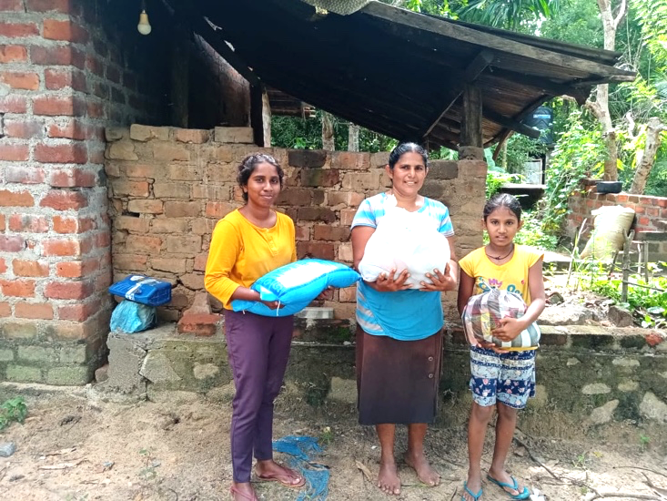

*Location: Polonnaruwa*

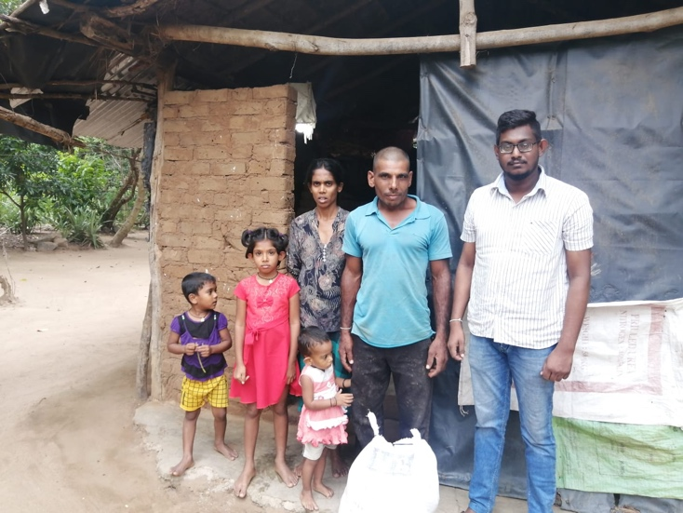

*Location: Monaragala*

The project was initiated with two generous donations from We Are One Sri Lanka (England) and students of United World College of S.E. Asia (Singapore). Since then, funds have poured in, showing the kindness of people everywhere who want to share their blessings with people of Sri Lanka suffering hunger in these unbelievably oppressed times of turmoil and uncertainty.

More families are being added whenever we receive funds for this project. Continuity of the Special Food Project is of paramount importance. People are hungry, we have to do what we can.

Our volunteer coordinators identify and screen deserving families. Details are recorded on a form designed for the purpose. This is submitted to the CandleAid office along with a photograph of the family. Once the family is approved, the coordinator receives LKR 10,000 per family. Sample lists of food items too are provided to the coordinator as a guideline.

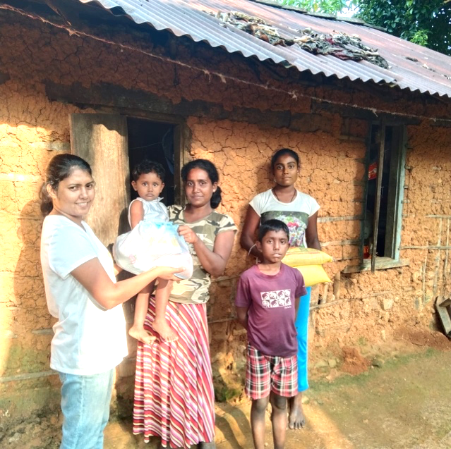

*Location: Meegahathanna*

The coordinator did the rest. He/She bought the dry rations, gifted it to the chosen recipients, submitted the bills to the office along with a simple letter of thanks from the recipient. A photograph is also taken when gifting the parcels.

At the beginning of the initiative in June 2022 there were challenges of all kinds suffocating the people. Fuel was not available making it difficult for the coordinators to reach the recipients.

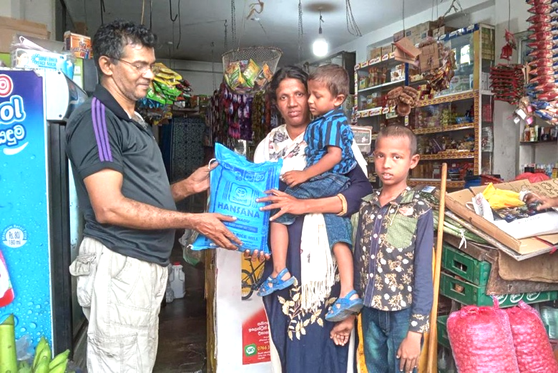89 volunteer coordinators worked the project and distributed 11.46 million LKR worth of dry rations to 1146 families all over Sri Lanka. The coordinators came from all walks of life and all races and all religions. Few had cars. They went by bus or bicycles or walked to reach the hungry to help them with dry rations. CandleAid is deeply grateful to the volunteer coordinators, who navigated this project to ensure that the most needy people received a fair quantity of badly needed rations enabling them to place food on the table for their starving families.

*Location: Maratuwa*

We also picked two schools, one from Panadura and one from Kalutara and arranged for meals to be cooked and given to children. Cost details are given below in the financial details of the project.

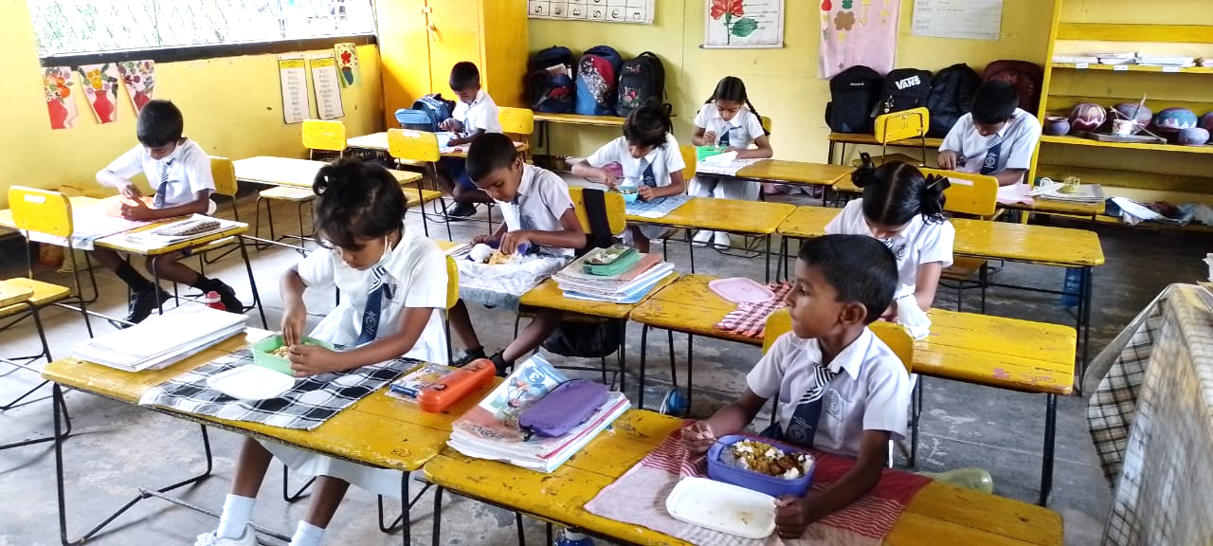

*“Adikarigoda Gyanissara kanishta vidyalaya” -Kaluthara*

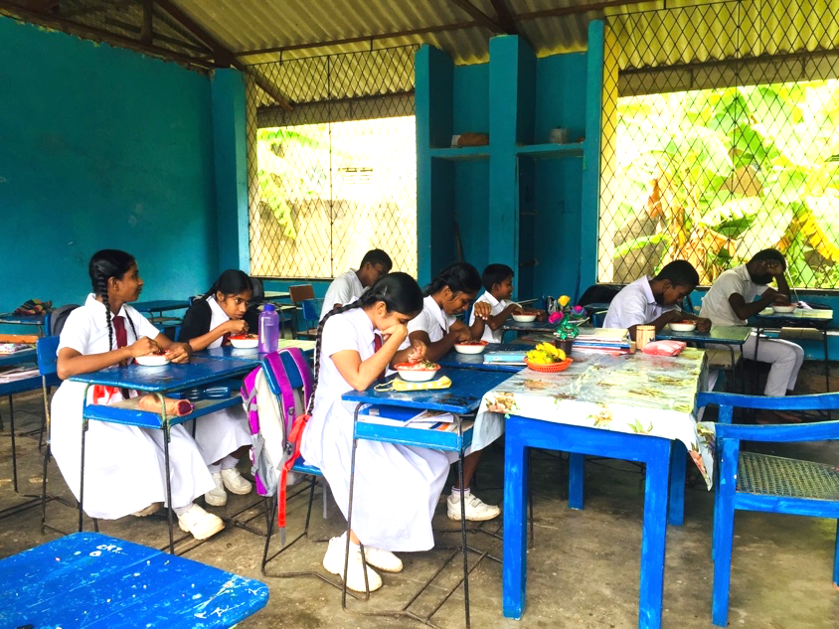

*Diamond Jubilee College -Panadura*

Project financial details (as at 31/12/2022):

|  |  |  |  |
| --- | --- | --- | --- |
|  | **Amount (LKR)** | **Remarks** | |
| Total received | 12,686,509 |  | |
| Allocated to the schools | 976,291 | Kalutara | 526,291 |
| Panadura | 450,000 |
| Dry ration distribution among families | 11,461,470 |  | |
| Current balance | 248,748 |  | |

All this was done in six months; a wonderful act of collective kindness.

None of this would have been possible without the generosity of CandleAid supporters who are rallying so willingly to fund this humanitarian cause.

Thank you is an understatement - We are deeply grateful.

Capt. Elmo Jayawardena

Founder President – CandleAid Lanka

05.01.2023